Why is the LED backwords? It is fixed
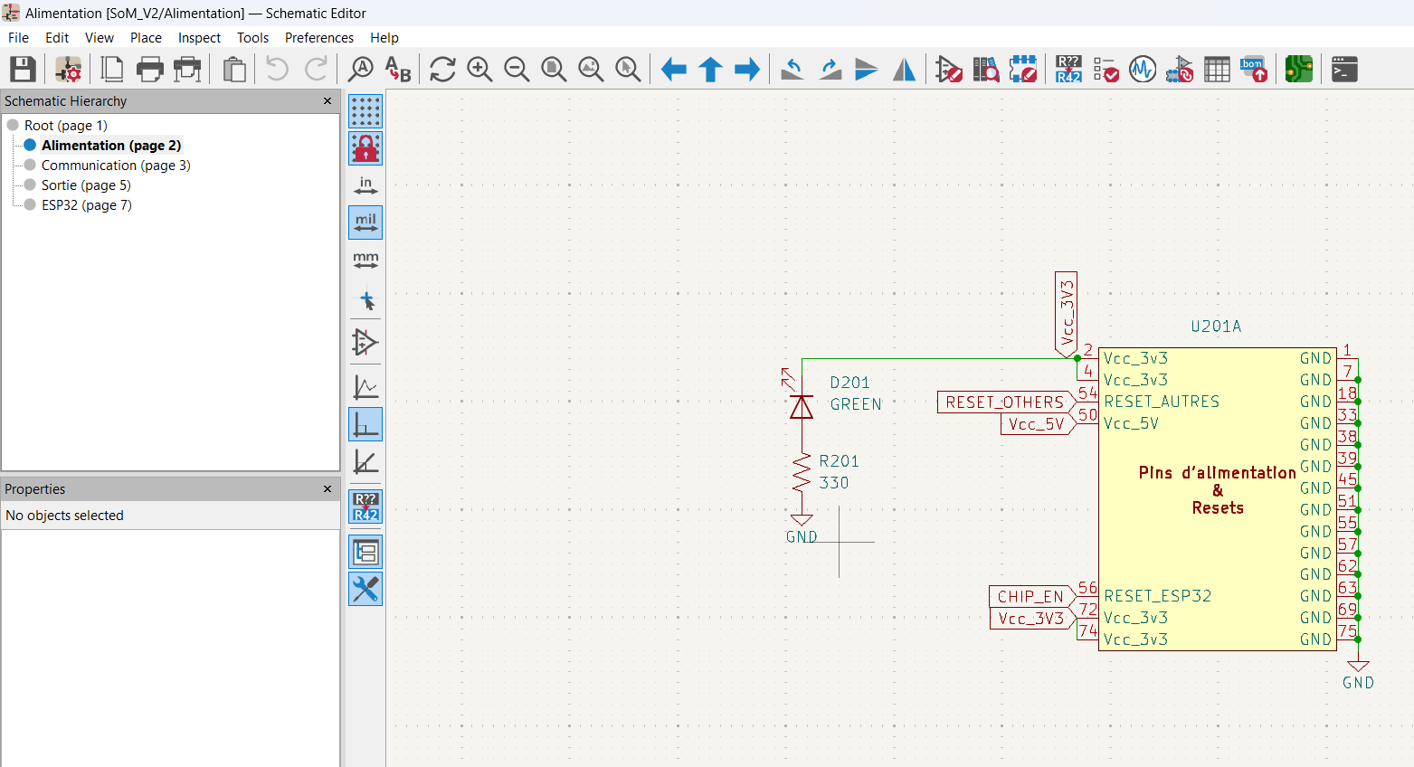

GND a la patte 3? Non, c Frank qui est cave, c sure que c pas un GND.
Mais le CAP(C303) me pose question? C fine
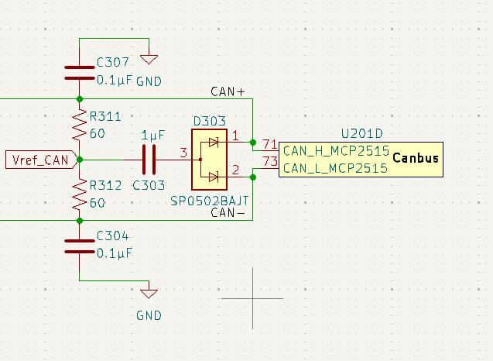

Will have to make sure? Should be fine
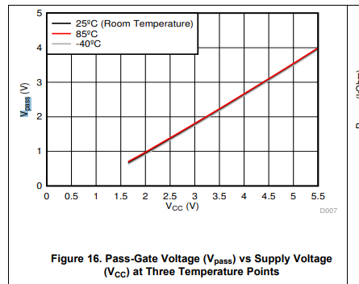
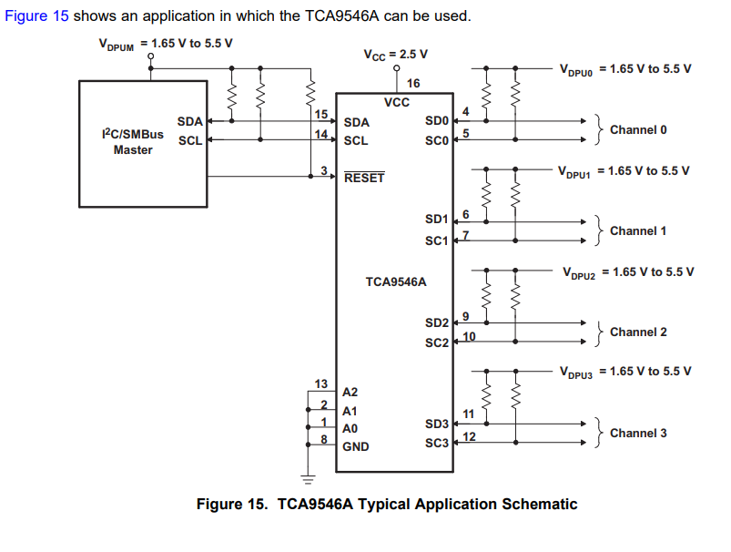

DS_FT231
Weird thing happening on pin 10 and 12
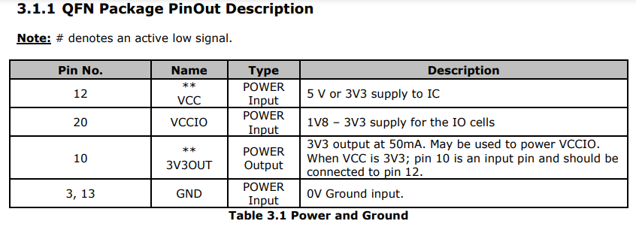

This is no longer used ???
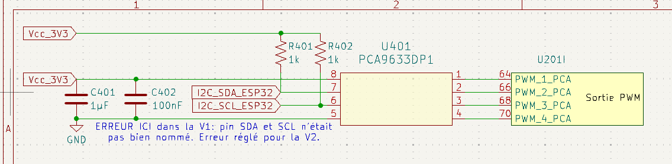

Good boy :
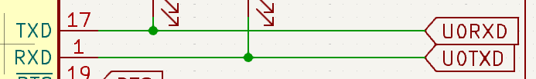
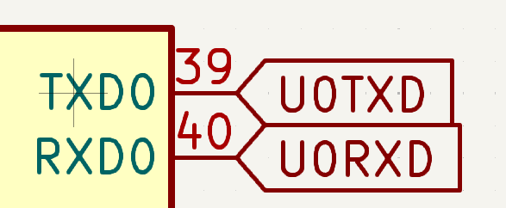

Mobo_V1

Why 2 of them? You could use one of them?
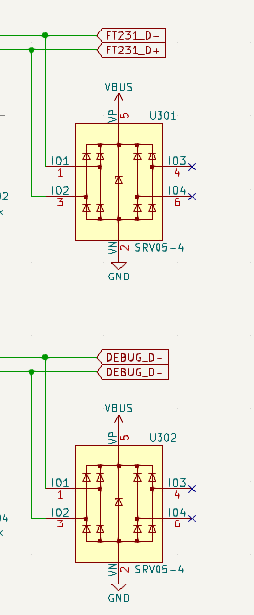

AMS1117-5.0
Me does not like This, with the 5V input that we have :
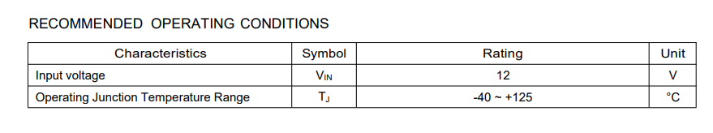

I will look at the mosfet later

